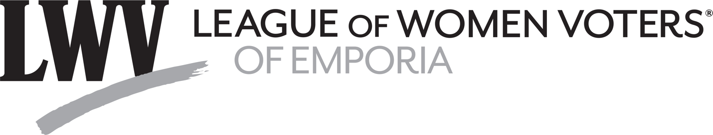
Kansas Legislature Week 3:
Kansas House Addresses Redistricting
During the third week of the Kansas Legislature, redistricting was addressed by the House, and several bills and appointment confirmations were passed by the Senate.
Tuesday, January 25, redrawing of U.S. House districts was before the House of Representatives. On the agenda was a redistricting plan adopted last week by the Kansas Senate, S Sub SB 355, which placed Lyon and surrounding counties in District 2, separated Lawrence from Douglas County and placed it in District 1, and divided Wyandotte County.
Rep. Burroughs (D) proposed an amendment that, among other things, would divide Lyon County between districts 1 and 2. That amendment was defeated by a vote of 32-82 with 1 present but not voting and 10 absent or not voting. Representatives Highland and E. Smith voted Nay and Representative Schreiber was absent or not voting.
An amendment by Rep. Garber (R) that would place Lyon County in District 1 was defeated by a vote of 29-82 with 14 absent or Not voting. Representatives Highland and E. Smith voted Nay, and Representative Schreiber was absent or not voting.
On further motion by Rep. Garber to amend S Sub SB 355, which also placed Lyon County in District 1 the vote was: Yeas 20; Nays 93; with 12 absent or Not voting. Representatives Highland and E. Smith voted Yea, and Representative Schreiber was absent or not voting.
On a motion by Rep. Sawyer (D) to amend S Sub SB 355 to divide Lyon County between Districts 1 and 2, the result was Yeas 36, Nays 77; Present but Not voting: 1; Absent or Not voting: 11. Highland voted Yea, E. Smith voted Nay, and Schreiber was absent or Not voting. On a motion by Rep. Clayton (D) to amend S Sub SB 355 to place Lyon County in District 1. The result: Yeas 19; Nays 92; Present but Not voting: 0; absent or Not voting: 14. Rep. Highland voted Yea, Rep. E. Smith voted Nay, and Schreiber was absent or not voting.
Wednesday, January 26, the House passed Sub SB 355 (known as Ad Astra II), the redistricting bill debated on Tuesday. The vote was: Yea 79; Nay 37; Present but Not voting: 2; Absent or Not voting: 7. Representatives Schreiber and E. Smith voted Yea; Representative Highland was present but not voting.
Also on January 26, the Senate voted on several appointments, which received support of 38 or 39 senators with no Nay votes. Senator Longbine voted Yea for all of the appointees: Kansas Development Finance Authority: Chris Donnelly; Kansas Public Employee Relations Board: Jonathan Gilbert; Kansas Development Finance Authority: Moniqueka Holloway; Kansas National Guard: Jason Nelson; Kansas Development Finance Authority: Jonathan Small; Kansas Racing and Gaming Commission: Sheryl Spalding; Kansas Commission on Veterans Affairs Office: William Turner; Kansas Public Employee Relations Board: William (Pat) Young; Kansas Public Employees Retirement Board of Trustees: Joanne Yun.
A final vote was taken on several Senate bills. SB 146 would transfer oversight of state certification of ignition interlock device manufacturers and service providers from the Kansas Department of Revenue to the Kansas Highway Patrol. The vote was: Yeas 39; Nays 0; Absent or Not Voting 1. Sen. Longbine voted Yea.
SB 337 would amend provisions pertaining to the pilot program established within the Technology-enabled Fiduciary Financial Institutions Act to clarify and retroactively codify the intended date for the issuance of a full charter to the Beneficient Company. The vote was: Yeas 39; Nays 0; Absent or Not Voting 1. Sen. Longbine voted Yea.
HB 2087 amends a current law that requires state agencies to provide an economic impact statement to the Director of the Budget that considers, among other things, the total annual implementation and compliance costs to businesses, local governments, or individuals. The vote was: Yeas 39; Nays 0; Absent or Not Voting 1. Sen. Longbine voted Yea.
Thursday, January 27: The following appointments were submitted to the Senate for confirmation as recommended by the Committee on Confirmation and Oversight:
For the State Board of Indigents Defense Services: Laurel Driskell; for the State Board of Indigents Defense Services: Michelle Ewert; State Banking Board: Taylor Hight; University of Kansas Hospital Authority: Jack Newman; State Board of Indigents Defense Services: Braden Perry; State Board of Tax Appeals: Devin Sprecker; University of Kansas Hospital Authority: Debbie Wilkerson. The vote for each was 39-0 with Sen. Longbine voting Yea.
SB 347 would enact the Attracting Powerful Economic Expansion Act that would establish new economic development incentives targeted at specific industries to firms that agree to invest at least $1billion within the State of Kansas and at their suppliers. The vote was: Yeas 32; Nays 7; Absent or Not Voting 1. Sen. Longbine voted Yea.
Friday, January 28: Both House and Senate met briefly for the introduction of bills, and no votes were taken.
This report was prepared by the League of Women Voters of Emporia Legislators Vote Tracking Committee: Bob Grover, Doug McGaw, Mary McGaw, Gail Milton, and Susan Fowler.
###

