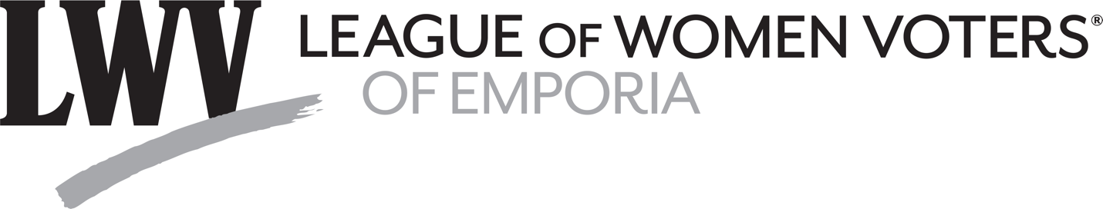
Kansas Legislature Update January 30-February 3
Since the first day of the current legislative session, 286 House bills and 161 Senate bills have been introduced, as reported in the February 3 report of “Legislative Policy Watch” published by the Kansas Rural Center.
The first votes on bills during the 2023 session of the Kansas Legislature are listed below. Lyon County Representatives Duane Droge (District 13), Mark Schreiber (District 60), and Eric Smith (District 76) voted Yea on all of the bills.
HB 2015 authorizes the designee of an employing agency to petition the court for an order requiring infectious disease testing.
HB 2016 clarifies how property held under a transfer-on-death deed is distributed when one beneficiary predeceases the grantor.
HB 2017 enacts the uniform family law arbitration act.
HB 2018 permits a will, or a copy of a will filed within six months after the death of the testator to be admitted to probate at any time.
Additional information on bills before the Legislature is found on the Legislature website: http://www.kslegislature.org/
Our committee will follow votes on the following topics: abortion, civil rights, climate change, children, government, gun legislation, higher education, LGBTQ issues, Medicaid expansion, school issues, taxes, vetoes, voting rights, and water issues.
During the last week, we noted the following among bills that were introduced:
HCR 5007 would amend the Kansas constitution, providing for consecutive term limits for senators and representatives; (1) after January 13, 2025, no individual shall be elected as a representative for more than four consecutive two-year terms, and (2) no individual shall be elected as a senator for more than two consecutive four-year terms.
HB 2290 authorizes the affiliation of Northwest Kansas Technical College and North Central Kansas Technical College with Fort Hays State University.
SB 123 declares that veterans and dependents or spouses who were stationed in the state for at least 11 months shall be considered a resident of the state for the purpose of tuition and fees at an institution of postsecondary education.
HB 2238 creates the fairness in women's sports act, restricting participation on women's teams to female students.
HB 2289 limits the power of the governmental ethics commission to issue subpoenas.
SB 137 declares it is unlawful to store a firearm that is not secured by a trigger lock mechanism, placed in a securely locked container or placed in some other location to be secure from any minor gaining access.
SB 156 would repeal statutes that prohibit, limit and otherwise restrict municipal regulation of firearms.
HB 2244, concerning firearms, provides permanent exemptions for postsecondary educational institutions.
HB 2245 authorizes the issuance of protective orders prohibiting the acquisition and possession of firearms.
Prepared by Emporia League of Women Voters members Bob Grover, Gail Milton, Doug McGaw, and Mary McGaw.

###

